El roscón de reyes
https://www.youtube.com/watch?v=eODrxgFv21E
Or simply type in Deliciousnessly Roscón de reyes into your YouTube search
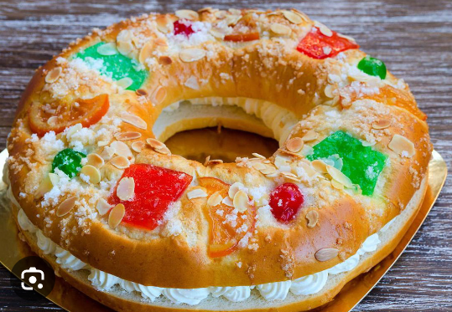
Ingredientes:
17g dry yeast 2 eggs
350g plain flour Pinch of salt
Approx. 200 ml milk 2 tbsp orange blossom water
Orange zest 50g softened butter
1tsp cinnamon 1 tsp water
100g sugar

Sliced almonds and candied fruits (to decorate)
300 ml thick cream, whisked (to fill)

El roscón de reyes
https://www.youtube.com/watch?v=eODrxgFv21E
Or simply type in Deliciousnessly Roscón de reyes into your YouTube search
Ingredientes:
17g dry yeast 2 eggs
350g plain flour Pinch of salt
Approx. 200 ml milk 2 tbsp orange blossom water
Orange zest 50g softened butter
1tsp cinnamon 1 tsp water
100g sugar

Sliced almonds and candied fruits (to decorate)
300 ml thick cream, whisked (to fill)

